



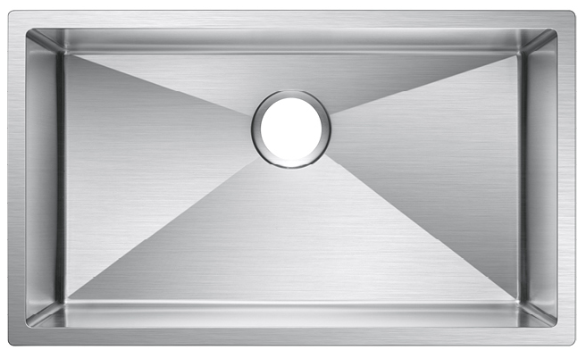

SINK DESCRIPTION

⯈ Undermount Single Bowl Kitchen sink

⯈ 18 gauge stainless steel 304, Satin finish

⯈ Off-set drain location

⯈ Installation Hardware included

⯈ Proprietary sound absorbing technology that undercoats the surface of this stainless steel kitchen sink keeps it silent and protected from condensation

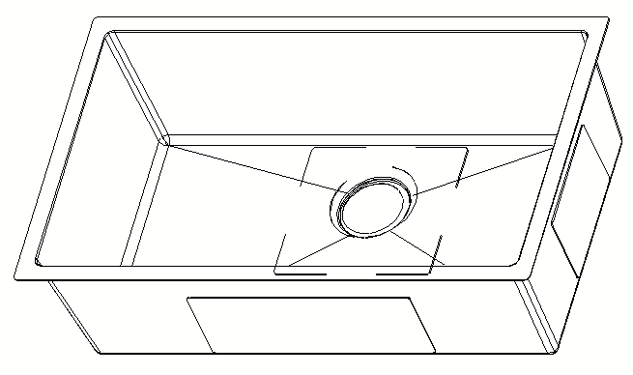

CUTOUT DIMENSTIONS

⯈Template included, template number HM3218

# PRODUCT COMPLIANCE

# ⯈ All product certified by IAPMO to meet standards ASME A112.19.3/CSA B45.4-17

WARRANTY

⯈ Limited lifetime warranty against material or manufacturing defects to the original consumer purchaser

TECHNICAL SPECIFICATION

**Specification**

|  |  |
| --- | --- |
| **Installation** | **Under-mount** |
| **Bowl area** | **Length: 32” (Outside)**  **30” (Inside)**  **Width: 17” (Outside)**  **16” (Inside)**  **Bowl Depth: 9”** |
| **Drain Hole** | **4-1/2”** |
| **Template** | **Required, Included** |

|  |  |  |
| --- | --- | --- |
|  |  |  |
| **HM-3218** | **9”** | **Off-set** |

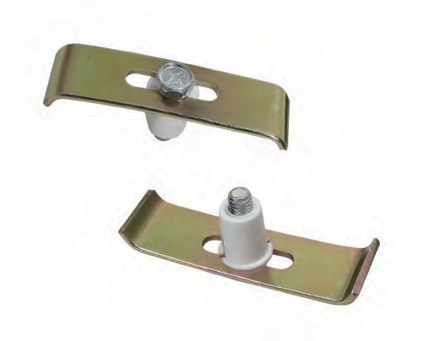



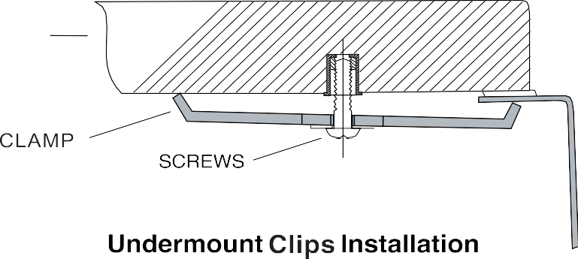

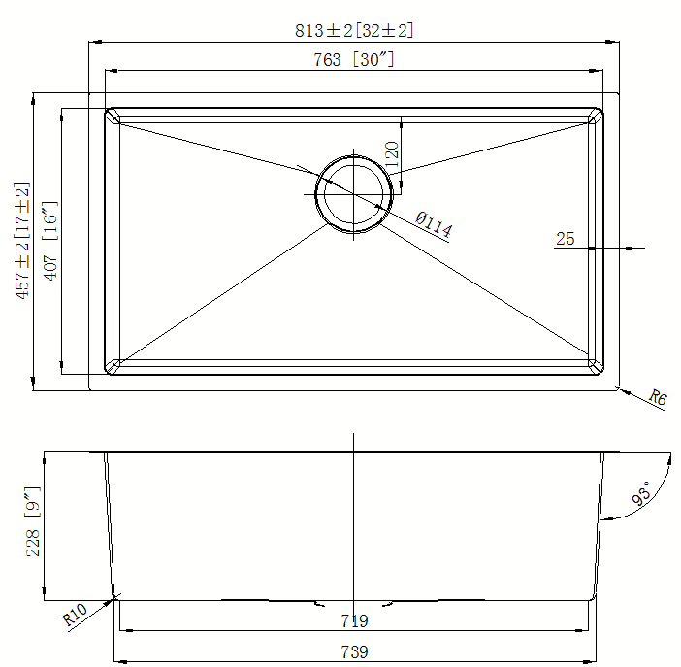

Note:

Install this product according to the installation instruction Minimum base cabinet size 33”

Consult an installer for confirmation.



FOR MORE INFORMAITON CALL: 571.393.7576

www.dynamicstonetools.com